Kodingan ini dibuat dengan bantuan AI Gemini. Berikut ini bentuk percakapannya:
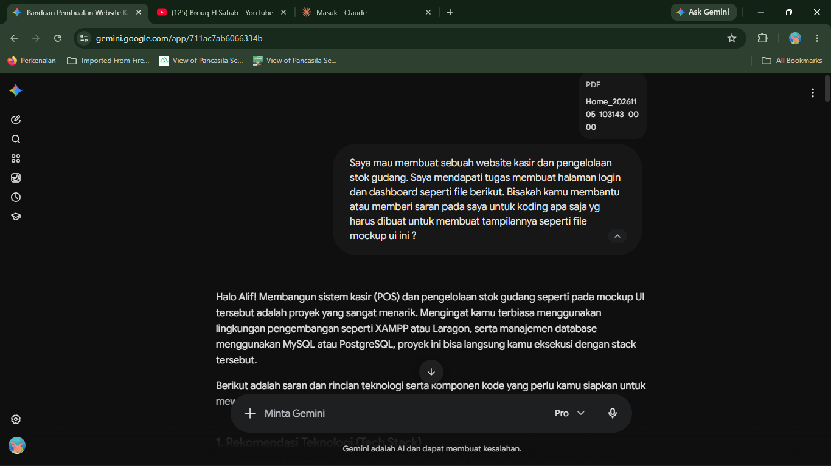
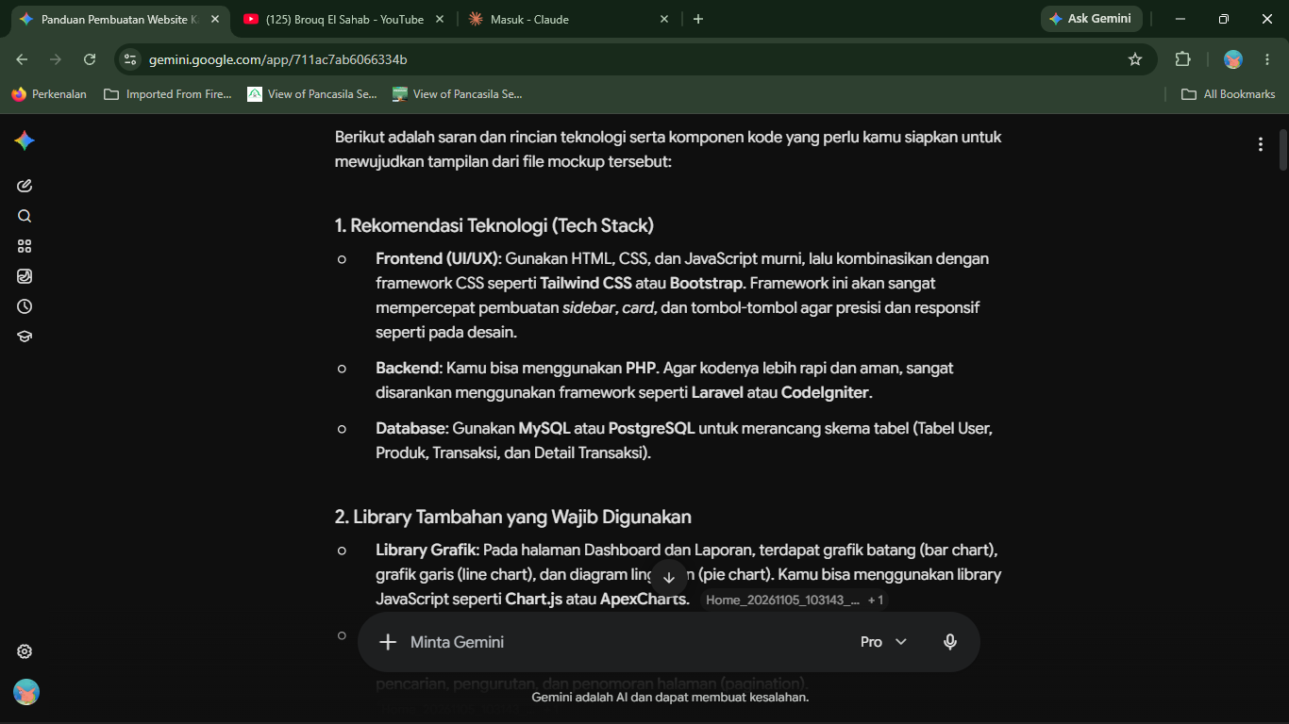
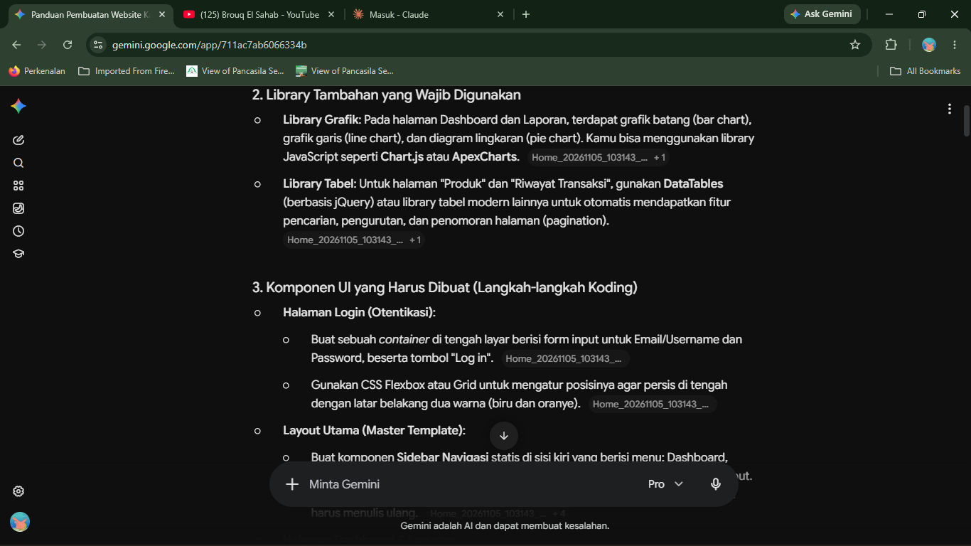
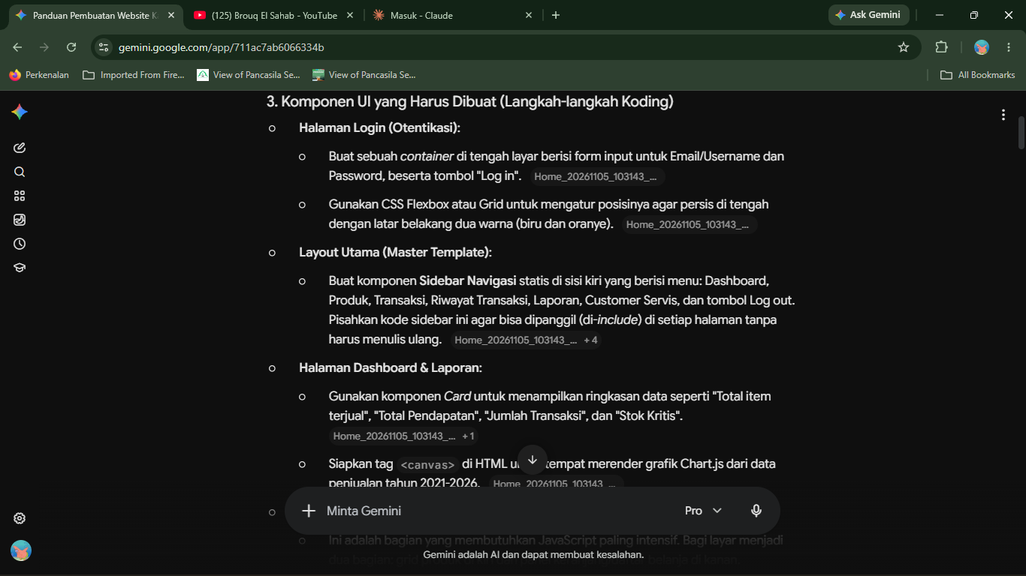
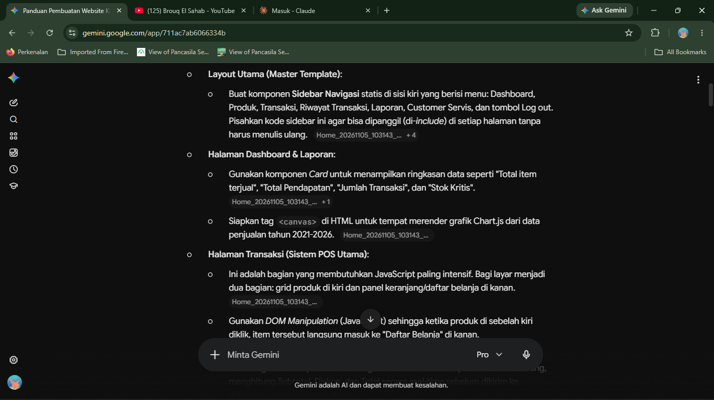
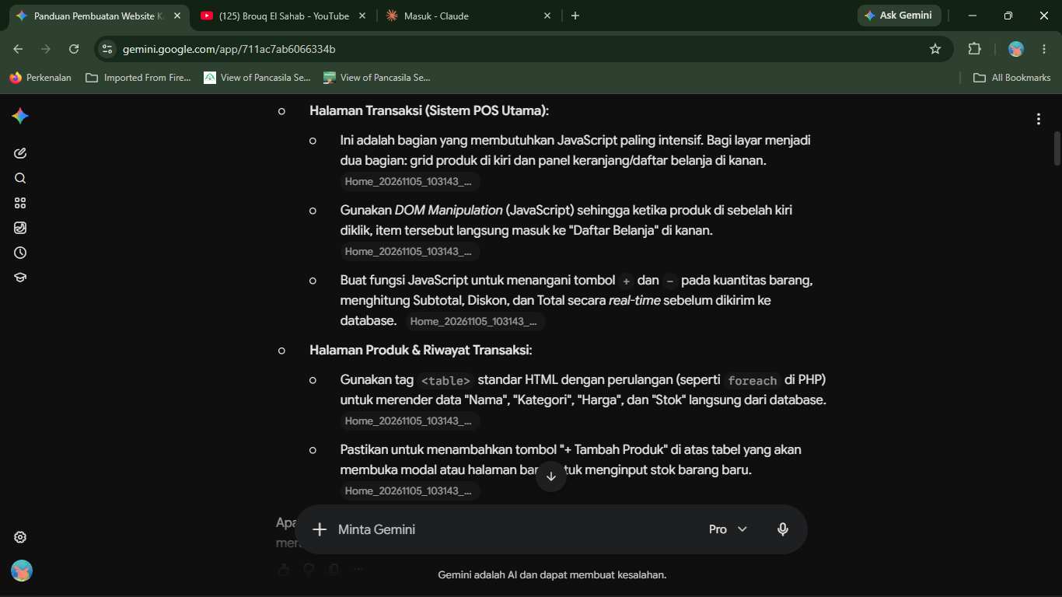
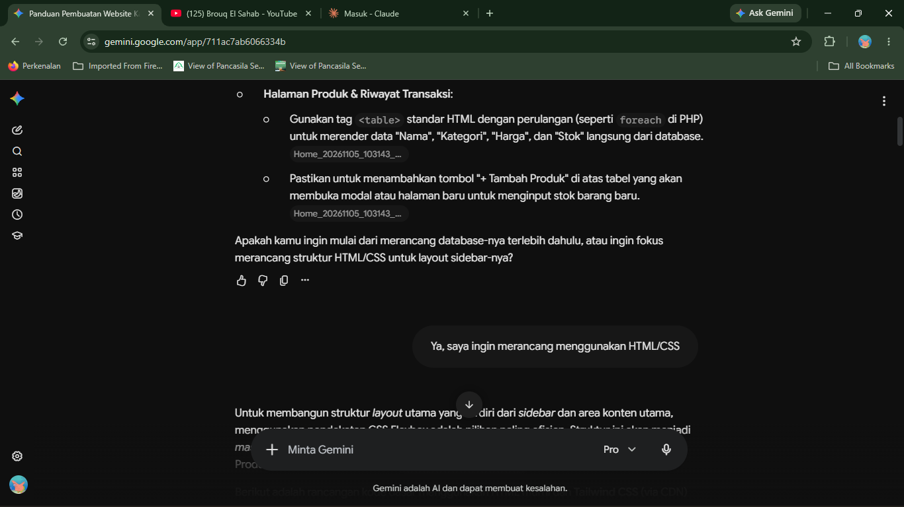
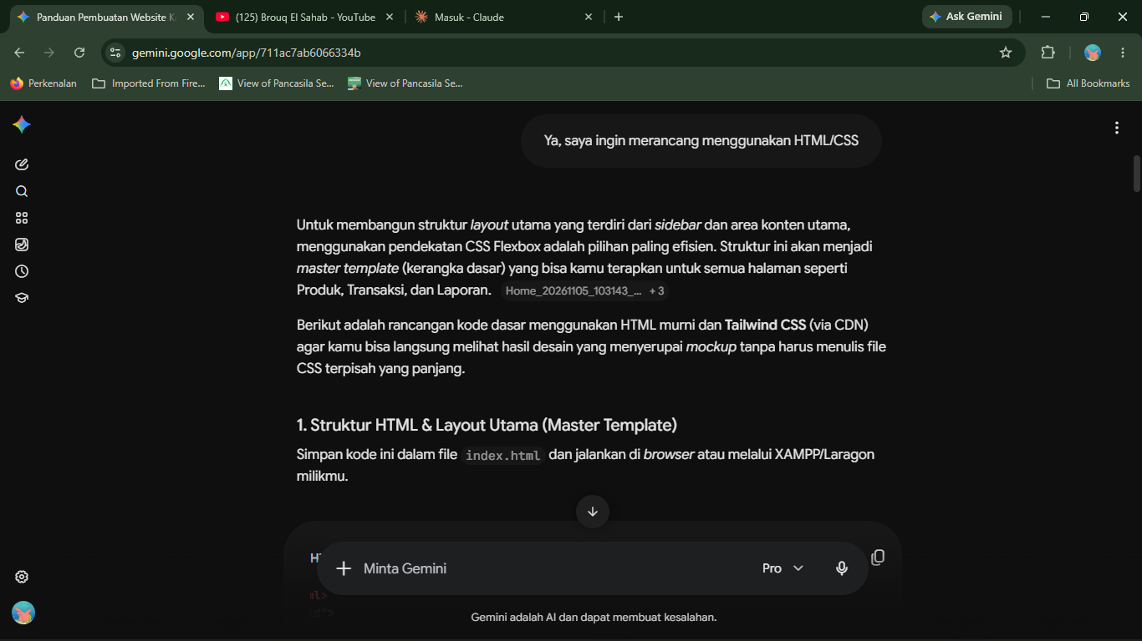
<!DOCTYPE html>
<html lang="id">
<head>
<meta charset="UTF-8">
<meta name="viewport" content="width=device-width, initial-scale=1.0">
<title>Cashie - Dashboard</title>
<!-- Menggunakan Tailwind CSS via CDN untuk styling cepat -->
<script src="https://cdn.tailwindcss.com"></script>
<style>
/* Konfigurasi warna kustom sesuai mockup */
theme: {
extend: {
colors: {
'cashie-blue': '#22225E', /* Warna biru gelap sidebar */
'cashie-bg': '#F0F4F8', /* Warna abu-abu terang main content */
'cashie-orange': '#FF8A00' /* Warna oranye aksen */
}
}
}
</style>
</head>
<body class="flex h-screen bg-[#F0F4F8] font-sans">

<!-- 1. SIDEBAR NAVIGASI -->
<aside class="w-64 bg-[#22225E] text-white flex flex-col justify-between">
<div>
<!-- Bagian Logo -->
<div class="flex items-center justify-center h-24 border-b border-indigo-800">
<div class="flex flex-col items-center gap-2 mt-4">
<!-- Placeholder Logo Cashie -->
<div class="w-16 h-16 bg-white rounded-full flex items-center justify-center text-[#22225E] font-bold text-xl">
C
</div>
<h1 class="text-2xl font-bold mb-4">Cashie</h1>
</div>
</div>

<!-- Bagian Menu -->
<nav class="mt-6 px-4">
<ul class="space-y-2">
<!-- Menu aktif dengan background putih -->
<li>
<a href="#" class="block px-4 py-3 bg-white text-[#22225E] rounded-lg font-semibold shadow">
Dashboard
</a>
</li>
<!-- Menu tidak aktif -->
<li>
<a href="#" class="block px-4 py-3 text-gray-300 hover:bg-indigo-800 hover:text-white rounded-lg transition">
Produk
</a>
</li>
<li>
<a href="#" class="block px-4 py-3 text-gray-300 hover:bg-indigo-800 hover:text-white rounded-lg transition">
Transaksi
</a>
</li>
<li>
<a href="#" class="block px-4 py-3 text-gray-300 hover:bg-indigo-800 hover:text-white rounded-lg transition">
Riwayat Transaksi
</a>
</li>
<li>
<a href="#" class="block px-4 py-3 text-gray-300 hover:bg-indigo-800 hover:text-white rounded-lg transition">
Laporan
</a>
</li>
<li>
<a href="#" class="block px-4 py-3 text-gray-300 hover:bg-indigo-800 hover:text-white rounded-lg transition">
Customer Servis
</a>
</li>
</ul>
</nav>
</div>

<!-- Bagian Footer Sidebar (User & Logout) -->
<div class="px-4 py-6 border-t border-indigo-800">
<div class="flex items-center justify-between px-4 py-2 bg-indigo-900 rounded-lg">
<span class="font-medium text-sm">User</span>
<a href="#" class="text-sm text-red-400 hover:text-red-300 font-semibold">Log out</a>
</div>
</div>
</aside>

<!-- 2. MAIN CONTENT AREA -->
<main class="flex-1 p-8 overflow-y-auto">
<header class="mb-8">
<h2 class="text-3xl font-bold text-gray-800">Dashboard</h2>
</header>

<!-- 3. GRID UNTUK CARD RINGKASAN DATA -->
<div class="grid grid-cols-1 md:grid-cols-2 lg:grid-cols-4 gap-6 mb-8">

<!-- Card 1: Total Item Terjual -->
<div class="bg-white p-6 rounded-2xl shadow-sm border border-gray-100 flex flex-col justify-between h-32">
<p class="text-gray-500 font-medium">Total item terjual</p>
<div class="flex items-end justify-between">
<h3 class="text-3xl font-bold text-gray-800">6.767</h3>
<span class="text-green-500 text-sm font-semibold bg-green-100 px-2 py-1 rounded">35%</span>
</div>
</div>

<!-- Card 2: Total Transaksi -->
<div class="bg-white p-6 rounded-2xl shadow-sm border border-gray-100 flex flex-col justify-between h-32">
<p class="text-gray-500 font-medium">Total Transaksi</p>
<div class="flex items-end justify-between">
<h3 class="text-3xl font-bold text-gray-800">2.212</h3>
<span class="text-green-500 text-sm font-semibold bg-green-100 px-2 py-1 rounded">35%</span>
</div>
</div>

<!-- Card 3: Total Pendapatan -->
<div class="bg-white p-6 rounded-2xl shadow-sm border border-gray-100 flex flex-col justify-between h-32">
<p class="text-gray-500 font-medium">Total Pendapatan</p>
<div class="flex items-end justify-between">
<h3 class="text-2xl font-bold text-gray-800">Rp 2.800.676.000</h3>
<span class="text-green-500 text-sm font-semibold bg-green-100 px-2 py-1 rounded">35%</span>
</div>
</div>

<!-- Card 4: Total Pelanggan Aktif -->
<div class="bg-white p-6 rounded-2xl shadow-sm border border-gray-100 flex flex-col justify-between h-32">
<p class="text-gray-500 font-medium">Total Pelanggan Aktif</p>
<div class="flex items-end justify-between">
<h3 class="text-3xl font-bold text-gray-800">67</h3>
<span class="text-red-500 text-sm font-semibold bg-red-100 px-2 py-1 rounded">-15%</span>
</div>
</div>

</div>

<!-- 4. AREA UNTUK GRAFIK (DIISI NANTI DENGAN CHART.JS) -->
<div class="bg-white p-6 rounded-2xl shadow-sm border border-gray-100 min-h-[300px]">
<h4 class="text-lg font-bold text-gray-700 mb-4">Penjualan dalam dua tahun terakhir</h4>
<!-- Tag canvas untuk render grafik -->
<canvas id="salesChart" class="w-full h-64 bg-gray-50 rounded border border-dashed border-gray-300 flex items-center justify-center">
<!-- Grafik akan dirender di sini via JavaScript -->
</canvas>
</div>
</main>

</body>
</html>

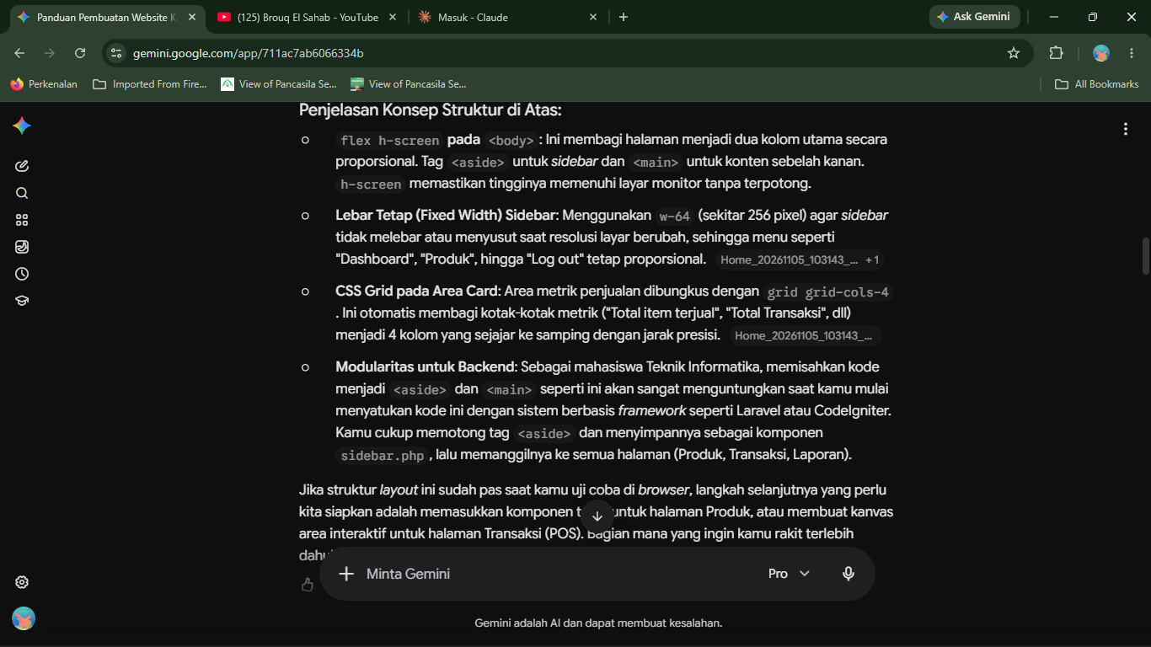
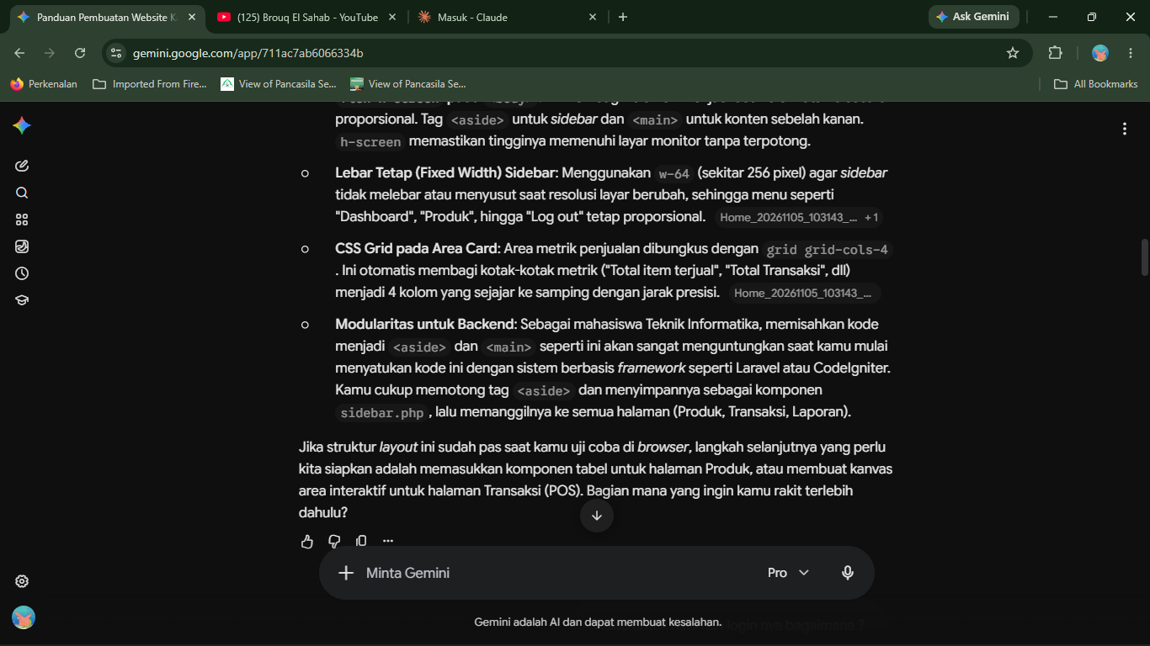
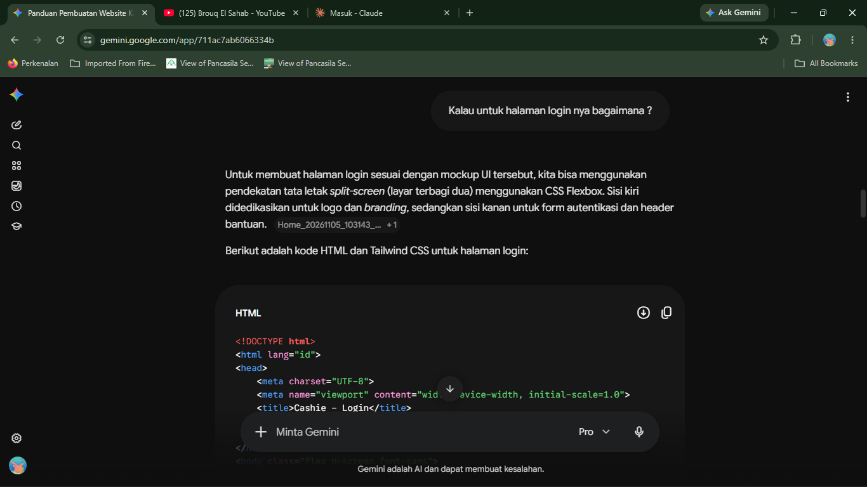
<!DOCTYPE html>
<html lang="id">
<head>
<meta charset="UTF-8">
<meta name="viewport" content="width=device-width, initial-scale=1.0">
<title>Cashie - Login</title>
<!-- Menggunakan Tailwind CSS via CDN -->
<script src="https://cdn.tailwindcss.com"></script>
</head>
<body class="flex h-screen font-sans">

<!-- 1. SISI KIRI (Branding & Logo) -->
<div class="hidden md:flex md:w-1/2 bg-[#22225E] items-center justify-center relative overflow-hidden">
<!-- Lingkaran Putih Tengah -->
<div class="bg-white rounded-full w-[28rem] h-[28rem] flex flex-col items-center justify-center shadow-2xl relative z-10">
<!-- Ikon Logo (Placeholder) -->
<div class="w-32 h-32 flex items-center justify-center mb-4">
<!-- Anda bisa mengganti SVG ini dengan gambar asli logo Cashie -->
<svg class="w-full h-full text-[#115E59]" fill="currentColor" viewBox="0 0 24 24">
<path d="M19 8h-1V3H6v5H5c-1.1 0-2 .9-2 2v11h22V10c0-1.1-.9-2-2-2zM8 5h8v3H8V5zm4 14.5c-1.93 0-3.5-1.57-3.5-3.5s1.57-3.5 3.5-3.5 3.5 1.57 3.5 3.5-1.57 3.5-3.5 3.5z"/>
</svg>
</div>
<!-- Teks Logo -->
<h1 class="text-5xl font-extrabold text-[#0F4C5C] tracking-tight">Cashie</h1>
</div>
</div>

<!-- 2. SISI KANAN (Form Login) -->
<div class="w-full md:w-1/2 bg-[#FF8A00] flex flex-col justify-between p-8 md:p-16 relative">

<!-- Header Kanan: Helpdesk -->
<div class="flex justify-end w-full">
<div class="flex flex-col items-center text-white cursor-pointer hover:opacity-80 transition">
<svg xmlns="http://www.w3.org/2000/svg" class="h-10 w-10 mb-1" fill="none" viewBox="0 0 24 24" stroke="currentColor" stroke-width="2">
<path stroke-linecap="round" stroke-linejoin="round" d="M15 10l4.553-2.276A1 1 0 0121 8.618v6.764a1 1 0 01-1.447.894L15 14M5 18h8a2 2 0 002-2V8a2 2 0 00-2-2H5a2 2 0 00-2 2v8a2 2 0 002 2z" />
</svg>
<span class="text-sm font-semibold">Helpdesk</span>
</div>
</div>

<!-- Area Tengah: Teks & Form -->
<div class="max-w-md w-full mx-auto flex-1 flex flex-col justify-center mt-[-40px]">
<!-- Judul Brand Kanan -->
<div class="mb-6 text-white">
<h2 class="text-5xl font-extrabold mb-2 shadow-sm">Cashie</h2>
<p class="text-lg font-semibold tracking-wide drop-shadow-md">Manage Smart. Grow Faster.</p>
</div>

<!-- Box Form Login -->
<div class="bg-[#22225E] rounded-3xl p-8 md:p-10 shadow-xl">
<h3 class="text-3xl font-bold text-white mb-2">Welcome!</h3>
<p class="text-gray-300 text-sm mb-8">Silahkan masuk ke akun kasir anda.</p>

<form action="#" method="POST">
<!-- Input Email/Username -->
<div class="mb-5">
<input type="text"
placeholder="Email atau username"
class="w-full px-6 py-4 rounded-full text-gray-700 bg-white focus:outline-none focus:ring-4 focus:ring-[#FF8A00] transition placeholder-gray-400 font-medium"
required>
</div>

<!-- Input Password -->
<div class="mb-8">
<input type="password"
placeholder="Password"
class="w-full px-6 py-4 rounded-full text-gray-700 bg-white focus:outline-none focus:ring-4 focus:ring-[#FF8A00] transition placeholder-gray-400 font-medium"
required>
</div>

<!-- Tombol Login -->
<div class="flex justify-end">
<button type="submit"
class="bg-[#FF8A00] hover:bg-orange-600 text-white font-bold py-3 px-10 rounded-full shadow-lg transition transform hover:scale-105 active:scale-95">
Log in
</button>
</div>
</form>
</div>
</div>

<!-- Spacer untuk menyeimbangkan Flexbox -->
<div></div>
</div>

</body>
</html>

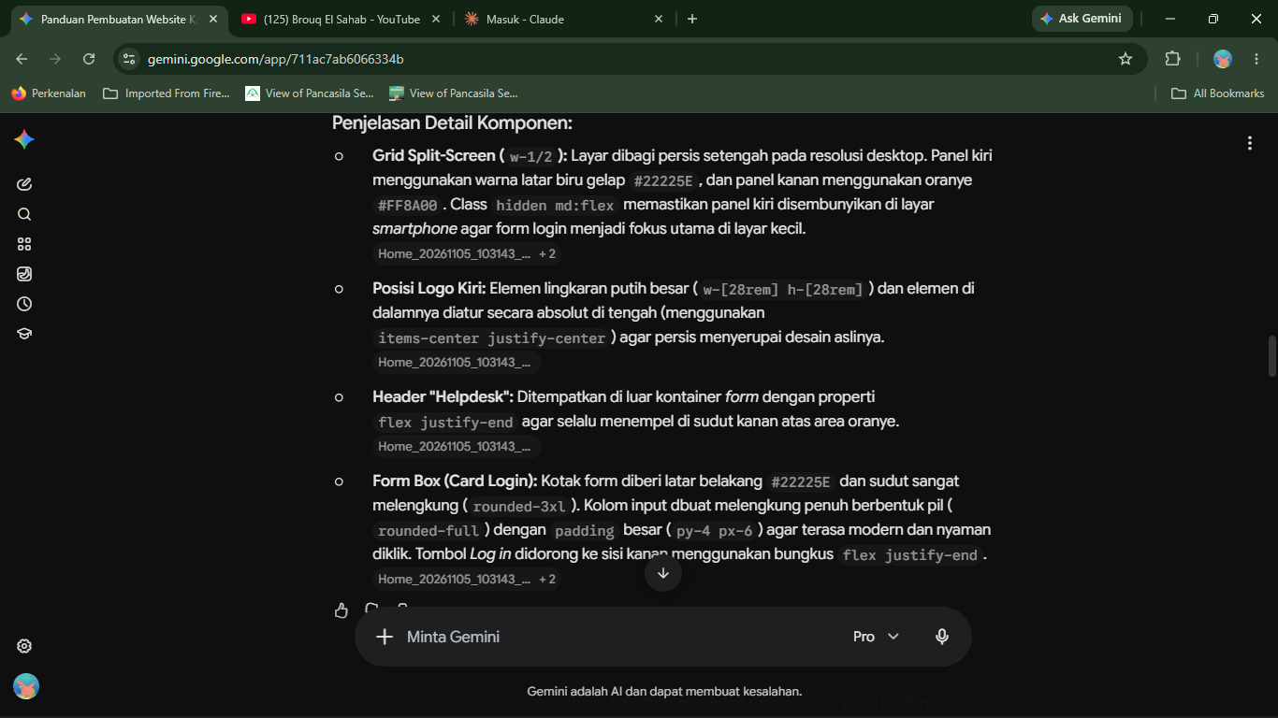
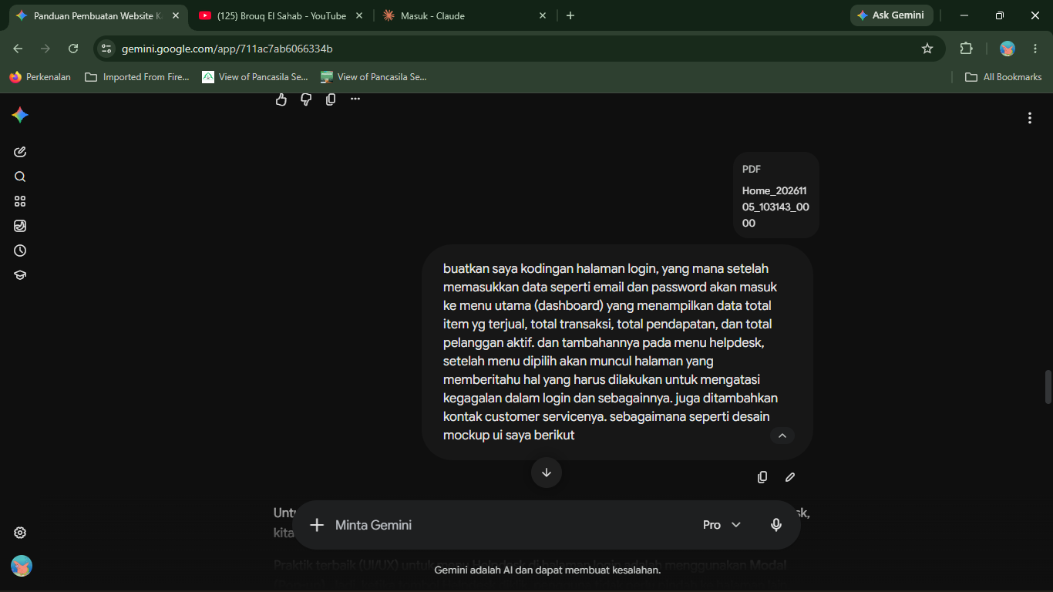
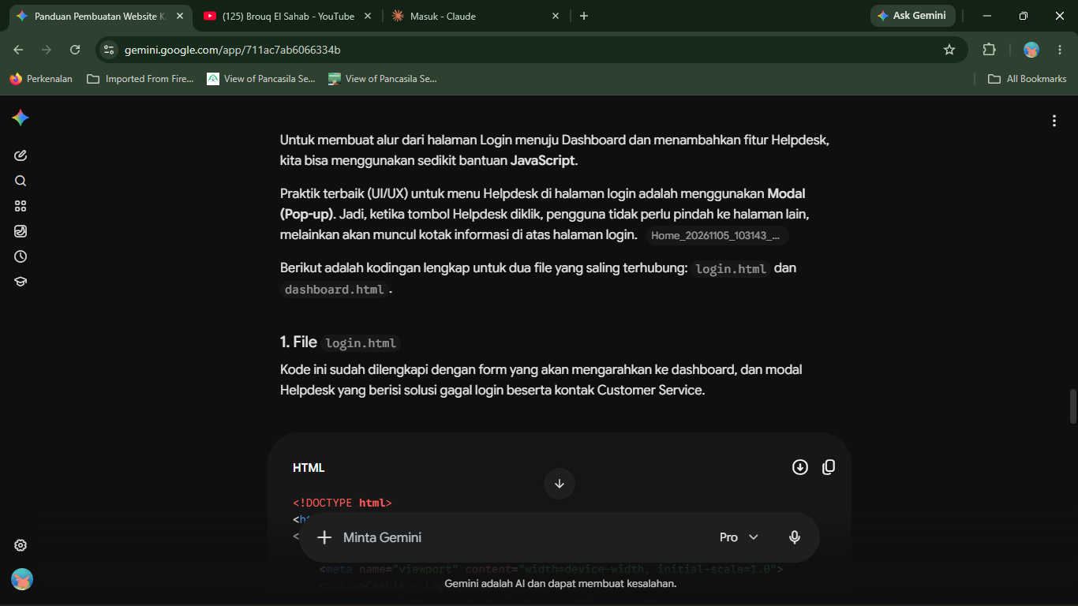
<!DOCTYPE html>
<html lang="id">
<head>
<meta charset="UTF-8">
<meta name="viewport" content="width=device-width, initial-scale=1.0">
<title>Cashie - Login</title>
<script src="https://cdn.tailwindcss.com"></script>
</head>
<body class="flex h-screen font-sans bg-[#FF8A00]">

<!-- MODAL HELPDESK (Tersembunyi secara default) -->
<div id="helpdeskModal" class="hidden fixed inset-0 bg-black bg-opacity-60 z-50 flex items-center justify-center transition-opacity">
<div class="bg-white p-8 rounded-3xl max-w-md w-full relative shadow-2xl">
<!-- Tombol Close Modal -->
<button onclick="closeHelpdesk()" class="absolute top-4 right-6 text-2xl text-gray-400 hover:text-red-500 font-bold">&times;</button>

<h2 class="text-2xl font-extrabold mb-4 text-[#22225E]">Pusat Bantuan (Helpdesk)</h2>
<p class="mb-3 text-gray-700 font-medium">Gagal login? Coba langkah berikut:</p>
<ul class="list-disc pl-5 mb-6 text-gray-600 space-y-1">
<li>Pastikan <b>Email/Username</b> sudah diketik dengan benar.</li>
<li>Periksa <b>Password</b> Anda (perhatikan huruf besar/kecil/Caps Lock).</li>
<li>Pastikan koneksi internet Anda stabil.</li>
</ul>

<div class="bg-blue-50 p-4 rounded-xl border border-blue-100">
<p class="font-bold text-[#22225E] mb-1">Kontak Customer Service:</p>
<p class="text-sm text-gray-700">📞 WhatsApp: <b>+62 812-3456-7890</b></p>
<p class="text-sm text-gray-700">✉️ Email: <b>support@cashie.com</b></p>
</div>
</div>
</div>

<!-- SISI KIRI (Branding & Logo) -->
<div class="hidden md:flex md:w-1/2 bg-[#22225E] items-center justify-center relative overflow-hidden">
<div class="bg-white rounded-full w-[28rem] h-[28rem] flex flex-col items-center justify-center shadow-2xl relative z-10">
<h1 class="text-5xl font-extrabold text-[#0F4C5C] tracking-tight mt-4">Cashie</h1>
</div>
</div>

<!-- SISI KANAN (Form Login) -->
<div class="w-full md:w-1/2 flex flex-col justify-between p-8 md:p-16 relative">

<!-- Header Kanan: Helpdesk (Ditambahkan fungsi onclick) -->
<div class="flex justify-end w-full">
<div onclick="openHelpdesk()" class="flex flex-col items-center text-white cursor-pointer hover:scale-105 transition transform">
<!-- Gunakan ikon/gambar helpdesk kamu di sini -->
<div class="w-12 h-12 mb-1 bg-white rounded-full flex items-center justify-center text-[#FF8A00] font-bold text-xl">?</div>
<span class="text-sm font-semibold">Helpdesk</span>
</div>
</div>

<!-- Area Tengah: Teks & Form -->
<div class="max-w-md w-full mx-auto flex-1 flex flex-col justify-center mt-[-40px]">
<div class="mb-6 text-white">
<h2 class="text-5xl font-extrabold mb-2 shadow-sm">Cashie</h2>
<p class="text-lg font-semibold tracking-wide drop-shadow-md">Manage Smart. Grow Faster.</p>
</div>

<div class="bg-[#22225E] rounded-3xl p-8 md:p-10 shadow-xl">
<h3 class="text-3xl font-bold text-white mb-2">Welcome!</h3>
<p class="text-gray-300 text-sm mb-8">Silahkan masuk ke akun kasir anda.</p>

<!-- FORM LOGIN (Ditambahkan event onsubmit) -->
<form onsubmit="prosesLogin(event)">
<div class="mb-5">
<input type="text" placeholder="Email atau username" class="w-full px-6 py-4 rounded-full text-gray-700 bg-white focus:outline-none focus:ring-4 focus:ring-[#FF8A00] font-medium" required>
</div>
<div class="mb-8">
<input type="password" placeholder="Password" class="w-full px-6 py-4 rounded-full text-gray-700 bg-white focus:outline-none focus:ring-4 focus:ring-[#FF8A00] font-medium" required>
</div>
<div class="flex justify-end">
<button type="submit" class="bg-[#FF8A00] hover:bg-orange-600 text-white font-bold py-3 px-10 rounded-full shadow-lg transition transform hover:scale-105">
Log in
</button>
</div>
</form>
</div>
</div>
<div></div>
</div>

<!-- SCRIPT JAVASCRIPT -->
<script>
// Fungsi untuk membuka dan menutup Modal Helpdesk
function openHelpdesk() {
document.getElementById('helpdeskModal').classList.remove('hidden');
}
function closeHelpdesk() {
document.getElementById('helpdeskModal').classList.add('hidden');
}

// Fungsi Simulasi Login
function prosesLogin(event) {
// Mencegah halaman ter-refresh saat tombol diklik
event.preventDefault();

// Di sini nantinya kamu bisa tambahkan logika PHP/Database
// Untuk saat ini, kita langsung arahkan ke halaman dashboard
window.location.href = 'dashboard.html';
}
</script>
</body>
</html>


<!DOCTYPE html>
<html lang="id">
<head>
<meta charset="UTF-8">
<meta name="viewport" content="width=device-width, initial-scale=1.0">
<title>Cashie - Dashboard</title>
<script src="https://cdn.tailwindcss.com"></script>
</head>
<body class="flex h-screen bg-[#F0F4F8] font-sans">

<!-- SIDEBAR -->
<aside class="w-64 bg-[#22225E] text-white flex flex-col justify-between">
<div>
<div class="flex items-center justify-center h-24 border-b border-indigo-800">
<h1 class="text-2xl font-bold mt-4">Cashie</h1>
</div>
<nav class="mt-6 px-4">
<ul class="space-y-2">
<li><a href="#" class="block px-4 py-3 bg-white text-[#22225E] rounded-lg font-semibold shadow">Dashboard</a></li>
<li><a href="#" class="block px-4 py-3 text-gray-300 hover:bg-indigo-800 rounded-lg">Produk</a></li>
<li><a href="#" class="block px-4 py-3 text-gray-300 hover:bg-indigo-800 rounded-lg">Transaksi</a></li>
</ul>
</nav>
</div>
<div class="px-4 py-6 border-t border-indigo-800">
<a href="login.html" class="block text-center w-full py-2 bg-red-500 hover:bg-red-600 rounded-lg font-semibold text-white transition">Log out</a>
</div>
</aside>

<!-- KONTEN UTAMA (Dashboard) -->
<main class="flex-1 p-8 overflow-y-auto">
<header class="mb-8">
<h2 class="text-3xl font-bold text-gray-800">Dashboard</h2>
</header>

<!-- Kumpulan Kartu Data -->
<div class="grid grid-cols-1 md:grid-cols-2 lg:grid-cols-4 gap-6">

<!-- Data 1: Total Item Terjual -->
<div class="bg-white p-6 rounded-2xl shadow-sm border border-gray-100 flex flex-col justify-between h-36">
<p class="text-gray-500 font-medium">Total item terjual</p>
<div class="flex items-end justify-between">
<h3 class="text-3xl font-bold text-gray-800">6.767</h3>
<span class="text-green-500 text-sm font-semibold bg-green-100 px-2 py-1 rounded">35%</span>
</div>
</div>

<!-- Data 2: Total Transaksi -->
<div class="bg-white p-6 rounded-2xl shadow-sm border border-gray-100 flex flex-col justify-between h-36">
<p class="text-gray-500 font-medium">Total Transaksi</p>
<div class="flex items-end justify-between">
<h3 class="text-3xl font-bold text-gray-800">2.212</h3>
<span class="text-green-500 text-sm font-semibold bg-green-100 px-2 py-1 rounded">35%</span>
</div>
</div>

<!-- Data 3: Total Pendapatan -->
<div class="bg-white p-6 rounded-2xl shadow-sm border border-gray-100 flex flex-col justify-between h-36">
<p class="text-gray-500 font-medium">Total Pendapatan</p>
<div class="flex items-end justify-between">
<h3 class="text-2xl font-bold text-gray-800">2.800.676.000</h3>
<span class="text-green-500 text-sm font-semibold bg-green-100 px-2 py-1 rounded">35%</span>
</div>
</div>

<!-- Data 4: Total Pelanggan Aktif -->
<div class="bg-white p-6 rounded-2xl shadow-sm border border-gray-100 flex flex-col justify-between h-36">
<p class="text-gray-500 font-medium">Total Pelanggan Aktif</p>
<div class="flex items-end justify-between">
<h3 class="text-3xl font-bold text-gray-800">67</h3>
<span class="text-red-500 text-sm font-semibold bg-red-100 px-2 py-1 rounded">15%</span>
</div>
</div>

</div>
</main>

</body>
</html>

